Thembelihle Shabangu
Code to Deliver: Building the SmartMed Inventory and Order Module

2.a. The System uses

- SQLite database
- Stored locally inside your project
- Managed by SQLAlchemy

b. Advantages For Project
- Simple
- Easy to control
- No internet needed
- Perfect for school
- Stable for demo
c. API integration means
- Cloud database
- Payment API
- External inventory API
- Online stock system
- Authentication API

3. Inventory
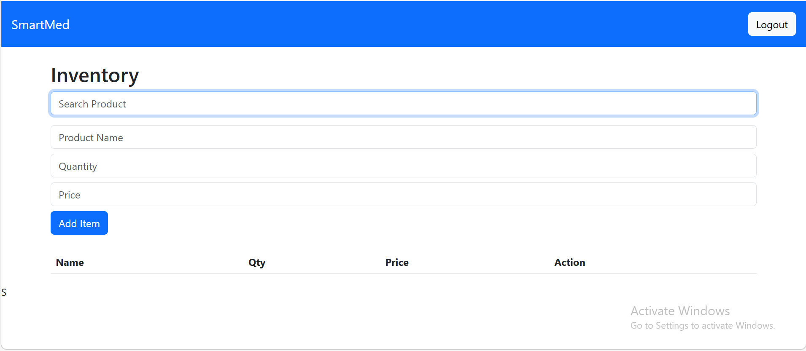

Where Product_name

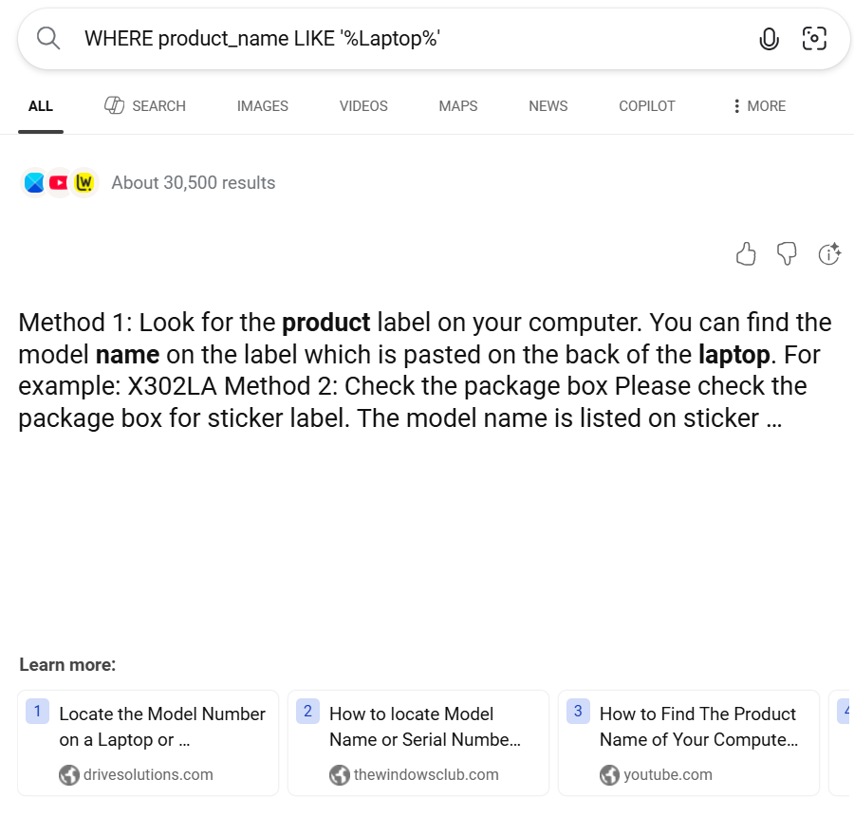

Inventory?Search


Dashboard

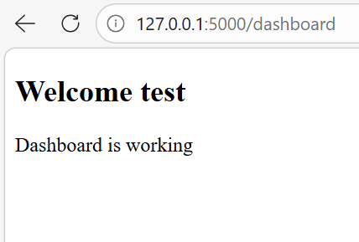

Login

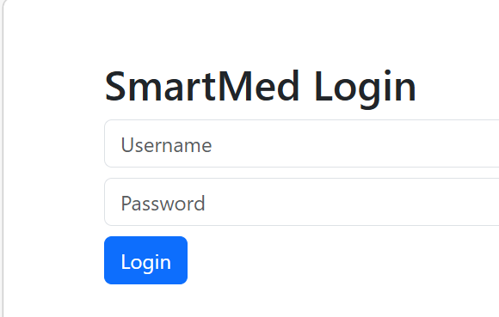

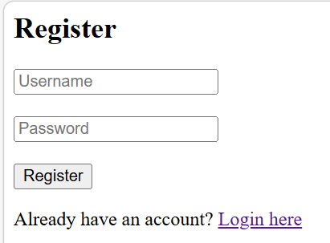
Register

Naming conventions
- inventory_bp
- auth_bp
- dashboard_bp
- User, Inventory, Order
- list_inventory()
- add_inventory()

Project files

- The documented route functions (with docstrings)

- The documented load_user function

- The documented model methods

- Clear inline comments inside major logic

Reusability and Readability

- Separate blueprints properly
- Keep models separate
- Use descriptive function names
- Add docstrings
- Avoid duplicate logic

Structure

SMARTMED_SYSTEM/
-
-app.py
-models.py
-
-routes/
- inventory.py
- auth.py
-
- templetes/
- statics/

4. Full Stack

- Login form
- Register form
- Inventory form
- Orders form (if added)

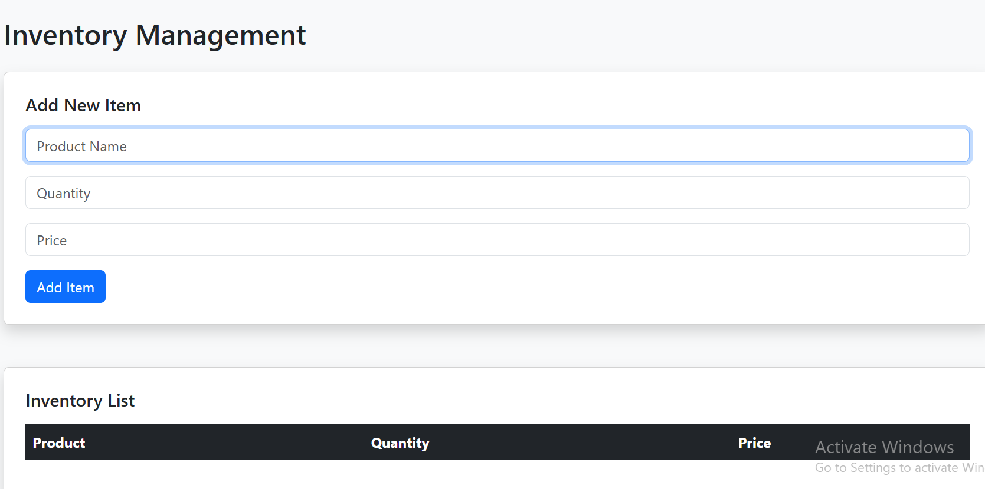

Orders

